**Daily Scrum or Standup Meeting**

Team name: _____Group 2____________________

Scrum Master: ___Emily Thomas_______________

Date:______10/4/22_________________________

| **Team Member** | **What did you do since the last scrum?** | **What do you plan to do before the next scrum?** | **What obstacles do you have?** |
| --- | --- | --- | --- |
| Emily Thomas | Backlog grooming for previous sprint | Start inventory item class and try to set up database model  Book next meeting in Library | Re-learning Django  First time working on a group software project |
| Andre Nguyen | Backlog grooming for previous sprint | Started the Add Employee class and trying to implement Add drink method | Relearning Django Framework  DevOps + Managing Github |
| Karl Poulson | Pushed Skeleton Project | TODO: Update with the picture/whiteboard screenshot | Merging branches |
| Maris Hurst | Backlog grooming for previous sprint | Copy user auth into project | Time, remembering Django |

# Burndown

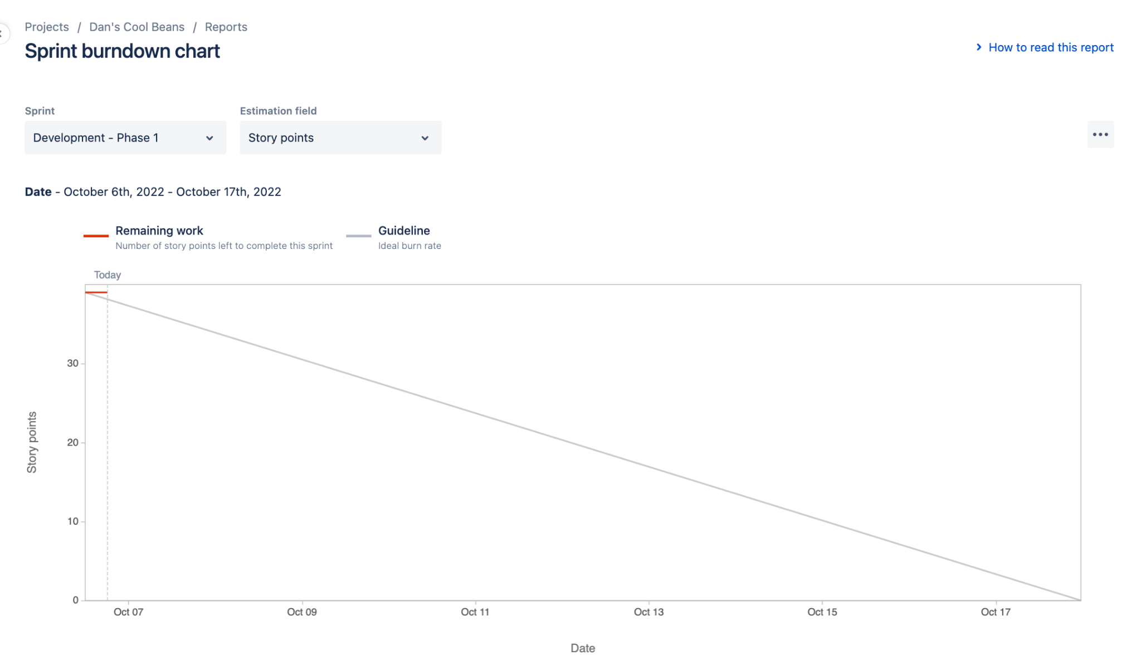

# Screenshot of you project board

